Website – Project plan

Table of Contents

Website – Project Plan 2

What is this assignment about? 2

Instructions 2

Part 1: Website Framework 2

Part 2: Low-Fidelity Prototype/Sketch 4

# Website – Project Plan

## What is this assignment about?

Welcome to Web Development 1! In this lab, we will explore your creative skills and plan the design of a website. The goal of this lab is to develop a plan for a website project. To complete this lab, you are required to:

* Take some time to think about an idea for a website. Search on the web for similar websites to identify what components they add to their pages.
* Fill out the framework listed below, describing different aspects of your website in each of the 5 (five) listed sections.
* Sketch how you plan to design that website (low-fidelity prototype) using digital tools or pen and paper. Attach the resulting image to this document and submit the file on Brightspace.

## Instructions

### Part 1: Website Framework

In this part of the assignment, you will create a framework that outlines your website’s main components and features. Please fill out each section below.

1. **Website purpose and target audience:**
   * Describe the primary purpose of your website (e.g., informational, e-commerce, entertainment, educational, etc.).
   * Identify your target audience (e.g., age group, interests, demographics).

**The primary purpose of this website is informational and educational. The main purpose is to help people that want to start travelling and visit new countries or cities but have no idea where to start or where to go. This website guides them in choosing a country or city by reading other reviews and opinions, provide information on hotels, transport, restaurants etc. for the country that they choose and can provide tutorials on how to take photos and what cameras to buy for those that enjoy photography and want to take many photos while travelling.**

**The main target audience is for the age of 18 and over that have travel and photography interests from anywhere around the world.**

1. **Similar websites:**
   * Find at least 3 (three) examples of similar websites.
   * Copy and paste their links below.
   * Describe the main components these websites have (e.g., images, videos, banners, menus, etc.)

<https://stuckincustoms.com/>

**This website contains camera reviews, news articles, photos from those that travelled, photography tutorials as well as videos of travelling and how to get a passport. They use strong and bold images of scenic places and have a bright red banner that catches your eye the second you open your website.**

[**https://www.findingtheuniverse.com/**](https://www.findingtheuniverse.com/)

**This website is a blog from a couple on travelling and photography tips as well as links to photography classes. It includes travel and packing tips, their opinion on each country and their experience in those countries. They use their own pictures and give advice for those that want to travel.**

[**https://travelphotodiscovery.com/**](https://travelphotodiscovery.com/)

**This blog website was created by a guy called Noel who travelled the world. On this website he shares travel advice, restaurant opinions and menus, culture tips, photography tips and his pictures that he took while travelling.**

1. **Content strategy:**
   * List the types of content you plan to include on your website (e.g., text, images, videos, articles, etc.).
   * Briefly explain the purpose and significance of each type of content.

**The content that I want to provide through my website is**

* **Information and tips on travelling and how to travel**

The purpose of adding this is to guide and help those that want to travel know and have a basic understanding of what they’re doing and how to get around. This helps them limit rookie travel mistakes as well as assure them and give them confidence in their journey.

* **Camera tips and advice on what to purchase and use and photography tutorials**

The purpose of adding this is to help those that want to take many pictures during their journey by reading advice and tips ion what camera to buy and choose. Those helps them, not choose a camera that’s expensive but doesn’t provide or aid in taking good quality photos. They can read the reviews and choose based on quality and durability.

* **Photos and videos that people took while travelling**

This can help people choose a country and see the pretty and scenic places and tourist attractions that they may like to visit.

* **News articles**

This helps people by gaining information on what is happening in that country and keep up to date with the news.

* **People’s opinions on the country they visited**

Having this content can help people read about others experiences in countries and give them the positive and negatives of the place rather than being influenced by Googles opinion and not enjoying the journey after spending lots of money.

* **Advice on how to get through the country and information on hotels, restaurants, transport etc.**

This can help by giving the traveller a head start by not have to worry about accommodation or transport for the country they plan to visit. This also can help them not be scammed while travelling as there will be reviews from other people that visited on what places to go and what to avoid.

1. **Interactive features:**
   * Identify any interactive features or functionality you plan to implement (e.g., contact forms, search bar, user registration, comments section, etc.).
   * Explain how these features will enhance the user experience.

**My plan is to provide a search bar for the user to navigate through the website, an opinion page for each heading and content that I plan to add and a contact page where the user can use to contact if there’s any issues.**

**People can interact with each other and give and take advice and can upload picture in the gallery section that they toom while travelling**

1. **Uniqueness:**

* What makes your website unique? Describe at least one factor that makes your website different from the others you have found.

**The unique feature about my website is that rather than making this blog about myself, this is a website where all can interact and share their tips, opinion and advise including photos pf their travel. All the websites’ either contain a gallery of photos from each country only or a blog about their travel. I think having multiple opinions is good and very efficient as its less biased and you have a more trusted opinion.**

### Part 2: Low-Fidelity Prototype/Sketch

In this part of the assignment, you will create a low-fidelity prototype or sketch to visualise the design of your website. You only need to sketch the website **main page**. You can use free online tools to create your prototype or draw it on paper and take a picture of it. Here are some recommended options:

* **Figma:** Figma is a powerful online design tool that allows you to create interactive prototypes. You can create a free account at [figma.com](https://www.figma.com/).
* **Pen & Paper:** If you prefer a more traditional approach, you can sketch your website layout on paper, take a picture of it, and paste it at the end of this document.

**Requirements for the Low-Fidelity Prototype/Sketch:**

* Create a visual representation of your website's homepage.
* Include key elements such as the logo, navigation menu, content sections, and interactive features.
* Focus on the layout and organisation of elements rather than detailed design.

**Website sketch:**

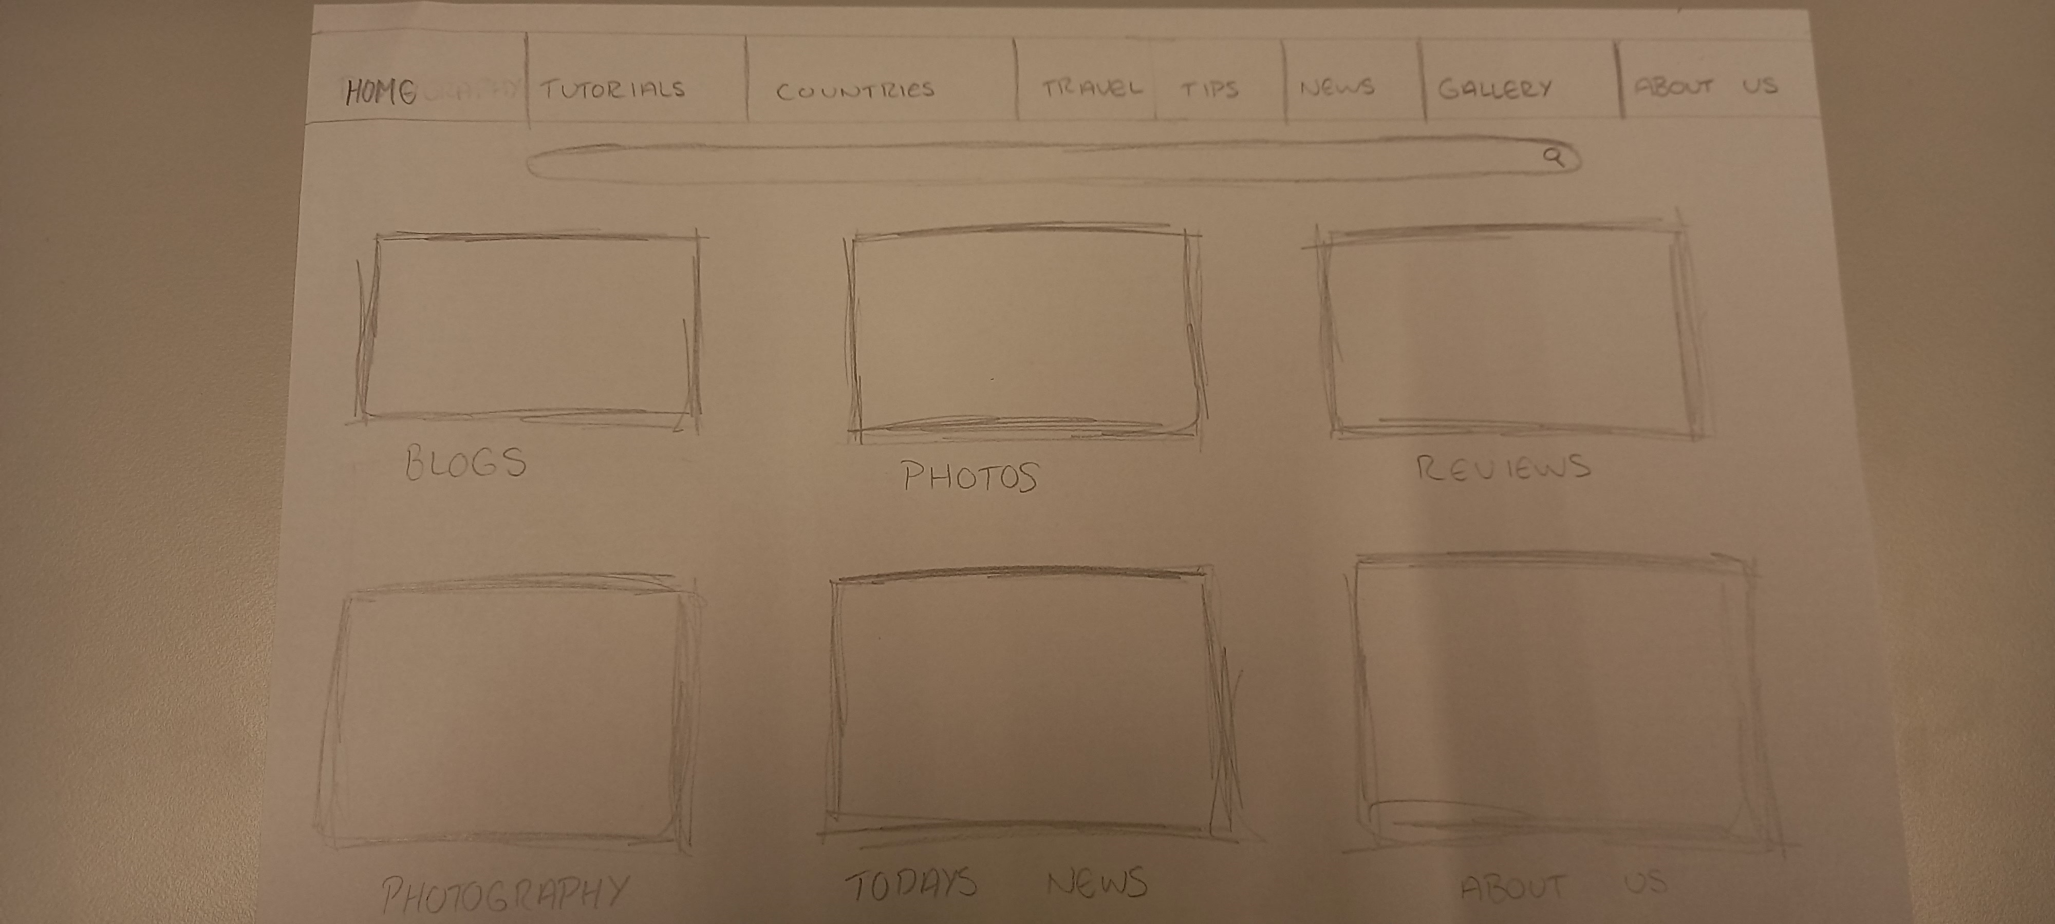

**Submission Instructions:**

Once you fill out the 5 points of the framework and paste the website sketch you have created, save this file and submit it on Brightspace. To do that:

* Go to our module page on Brightspace, click **Assessment** at the top menu, and select **Assignments**. Click on **Lab 1 – Design and plan a website,** and you will see the following screen.

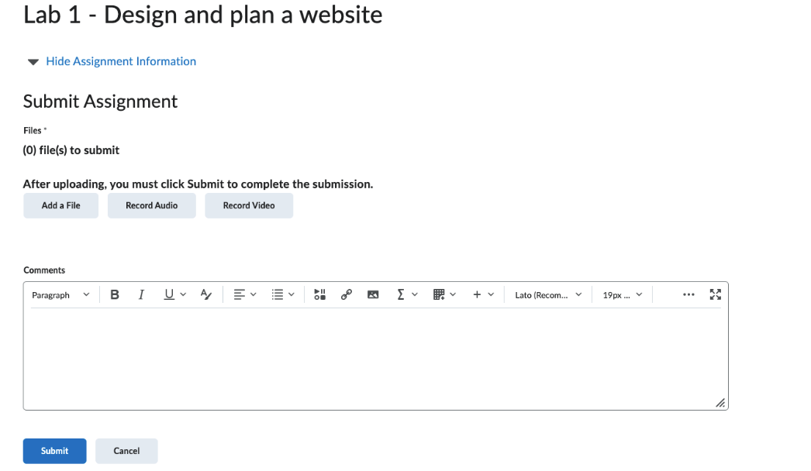

* Click on Add file and then on My computer, then on Upload and find the filled-out form (saved as a PDF file) on your computer.
* Click on Add, and once you have added the correct file, click Submit.
* You should submit your assignment by the end of the lab.

**Demonstrating your assignment:**

Once you finish and submit your assignment, you must demonstrate it to your lab instructor to get your marks.